
Unlocking the Power of Big Data
Professor: Hachem Sfar
Student Name: Chun-Han Chueh (Victoria)
Student ID: 22026614
Github link: https://github.com/VictoriaChueh/Unlocking-the-Power-of-Big-Data_Final.git

- Data Platform Used
Databricks
- Technologies
Databricks (using Delta tables, notebook, SQL, and Databricks dashboards...)

- Data Source
3.1 Frankfurter API
- URL: https://api.frankfurter.app/
- Provides: Exchange rate data (daily rates of EUR against other currencies)
- Table: fx_rates_eur
- Columns: date, base, currency, rate
- Purpose: Time series analysis (e.g., monthly average exchange rates, rate changes)
  - REST Countries API
- URL: https://restcountries.com/
- Provides: Basic country information (population, region, currency)
- Table: countries_currency
- Columns: country, region, population, currency, currency_name
- Purpose: Analyze population distribution, regional comparisons, and currency-country relationships

- Core Technical Requirements
4.1 Data Ingestion
API Source 1
# 4.1 Data Ingestion
# Import required libraries
import requests
import pandas as pd

# Parameterize the date range
start_date = "2024-01-01"
end_date = "2024-12-31"
base_ccy = "EUR"

# Build API URL
url = f"https://api.frankfurter.app/{start_date}..{end_date}?from={base_ccy}"

# Call the API
resp = requests.get(url, timeout=30)
resp.raise_for_status()
payload = resp.json()

# Flatten JSON to rows: one row per (date, currency, rate)
rows = []
for d, rate_map in (payload.get("rates") or {}).items():
for ccy, rate in rate_map.items():
rows.append({
"date": d, # string YYYY-MM-DD
"base": payload.get("base"),
"currency": ccy,
"rate": float(rate)
})

# Convert to pandas then to Spark DataFrame
pdf_fx = pd.DataFrame(rows)
df_fx = spark.createDataFrame(pdf_fx)

# Quick checks
print(f"fx rows: {df_fx.count()}")
df_fx.printSchema()
df_fx.show(5)

API Source 2
# 4.1 Data Ingestion
# Import libraries
import requests
import pandas as pd

# API endpoint: limit to required fields for efficiency
countries_url = "https://restcountries.com/v3.1/all?fields=name,population,region,cca2,currencies"

# Call the API
resp = requests.get(countries_url, timeout=60)
resp.raise_for_status()
countries = resp.json()

# Normalize to tabular rows: expand one row per currency per country
rows = []
for c in countries:
name = (c.get("name") or {}).get("common")
population = c.get("population")
region = c.get("region")
cca2 = c.get("cca2")
currencies = c.get("currencies") or {}

# If a country has currencies, expand each; else keep one row with None currency
if currencies:
for code, info in currencies.items():
rows.append({
"country": name,
"cca2": cca2,
"region": region,
"population": population,
"currency": code,
"currency_name": (info or {}).get("name"),
})
else:
rows.append({
"country": name,
"cca2": cca2,
"region": region,
"population": population,
"currency": None,
"currency_name": None,
})

# Convert to pandas then to Spark DataFrame
pdf_cty = pd.DataFrame(rows)
df_cty = spark.createDataFrame(pdf_cty)

# Quick checks
print(f"countries rows: {df_cty.count()}")
df_cty.printSchema()
df_cty.show(5)

  - Data Cleaning, Preparation and analysis
# 4.2 Data Cleaning, Preparation and analysis
# Import Spark functions
from pyspark.sql.functions import col

# Clean FX data: drop nulls and cast rate
df_fx_clean = (
df_fx
.dropna(subset=["date", "currency", "rate"])
.withColumn("rate", col("rate").cast("double"))
)

# Clean country data: ensure core columns and cast population
df_cty_clean = (
df_cty
.dropna(subset=["country"]) # core identity column
.withColumn("population", col("population").cast("long"))
)

# Sanity check
print("fx_clean rows:", df_fx_clean.count())
print("cty_clean rows:", df_cty_clean.count())

  - Data Storage
# 4.3 Data Storage
# Persist cleaned dataframes as Delta managed tables
df_fx_clean.write.mode("overwrite").format("delta").saveAsTable("fx_rates_eur")
df_cty_clean.write.mode("overwrite").format("delta").saveAsTable("countries_currency")

print("Tables saved: fx_rates_eur, countries_currency")

# 4.3 Data Storage
# Load tables back to verify
fx_tbl = spark.table("fx_rates_eur")
cty_tbl = spark.table("countries_currency")

fx_tbl.show(3)
cty_tbl.show(3)

  - SQL Analysis
Query 1: Monthly Average EUR→USD Exchange Rate
# 4.4 SQL Analysis / Query 1: Monthly Average EUR→USD Exchange Rate

%sql

SELECT
date_format(to_date(date), 'yyyy-MM') AS month,
AVG(rate) AS avg_rate_usd
FROM fx_rates_eur
WHERE currency = 'USD'
GROUP BY date_format(to_date(date), 'yyyy-MM')
ORDER BY month;

Query 2: Top 10 Most Populous Countries by Region
# 4.4 SQL Analysis / Query 2: Top 10 Most Populous Countries by Region

%sql
WITH ranked AS (
SELECT
region,
country,
population,
ROW_NUMBER() OVER (PARTITION BY region ORDER BY population DESC) AS rn
FROM countries_currency
WHERE population IS NOT NULL
)
SELECT
region,
country,
population
FROM ranked
WHERE rn <= 10
ORDER BY region, population DESC;

Query 3: Month-over-Month Change of Monthly Average EUR→USD Exchange Rate
# 4.4 SQL Analysis / Query 3: Month-over-Month Change of Monthly Average EUR→USD Exchange Rate

%sql

WITH m AS (
SELECT
date_format(to_date(date), 'yyyy-MM') AS month,
AVG(rate) AS avg_usd
FROM fx_rates_eur
WHERE currency = 'USD'
GROUP BY date_format(to_date(date), 'yyyy-MM')
)
SELECT
month,
avg_usd,
avg_usd - LAG(avg_usd) OVER (ORDER BY month) AS m2m_change
FROM m
ORDER BY month;

Query 4: Link Each Country’s Currency to Its Average Exchange Rate
# 4.4 SQL Analysis / Query 4: Link Each Country’s Currency to Its Average Exchange Rate

%sql

WITH avg_fx AS (
SELECT
currency,
AVG(rate) AS avg_rate_vs_eur
FROM fx_rates_eur
GROUP BY currency
)
SELECT
c.region,
c.country,
c.currency,
a.avg_rate_vs_eur
FROM countries_currency c
JOIN avg_fx a
ON c.currency = a.currency
WHERE c.currency IS NOT NULL
ORDER BY c.region, c.country;

  - Notebook Analysis
# 4.5 Notebook Analysis
# Ensure using the correct schema
spark.sql("USE SCHEMA default")

# Load Delta tables created in previous steps
df_fx = spark.table("fx_rates_eur")
df_cty = spark.table("countries_currency")

# Inspect schemas and a few sample rows
print("=== Schemas ===")
df_fx.printSchema() # FX: date (string), base, currency, rate (double)
df_cty.printSchema() # Countries: country, cca2, region, population (long), currency, currency_name

print("=== Samples ===")
df_fx.show(5)
df_cty.show(5)

Descriptive Stats
# 4.5 Notebook Analysis / Descriptive Stats
# Descriptive statistics for FX rates (numeric column)
print("=== FX rates descriptive stats ===")
df_fx.describe(["rate"]).show()

# Descriptive statistics for population (numeric column)
print("=== Countries population descriptive stats ===")
df_cty.describe(["population"]).show()

GroupBy + Aggregation
#4.5 Notebook Analysis / GroupBy + Aggregation

from pyspark.sql.functions import avg, sum, col

# 1) Average FX rate per currency (descending)
print("=== Average FX rate per currency ===")
df_fx.groupBy("currency").agg(avg("rate").alias("avg_rate")) \
.orderBy(col("avg_rate").desc()) \
.show(20, truncate=False)

# 2) Total population per region (descending)
print("=== Total population per region ===")
df_cty.groupBy("region").agg(sum("population").alias("total_population")) \
.orderBy(col("total_population").desc()) \
.show(truncate=False)

JOIN
#4.5 Notebook Analysis / JOIN

from pyspark.sql.functions import avg, col

# Join countries and FX by currency; keep only rows with currency info on both sides
df_join = df_cty.join(df_fx, on="currency", how="inner")

# Compute average annual FX rate vs EUR per country
df_country_avg_fx = (
df_join.groupBy("country", "region", "currency")
.agg(avg("rate").alias("avg_rate_vs_eur"))
.orderBy(col("avg_rate_vs_eur").desc())
)

print("=== Country-level average FX vs EUR (2024) ===")
df_country_avg_fx.show(20, truncate=False)

Time Series Processing
#4.5 Notebook Analysis / Time Series Processing: Convert Date to DATE and Calculate Monthly Average Exchange Rate

from pyspark.sql.functions import to_date, date_format

# Cast date string to DATE type, then extract 'YYYY-MM' as month
df_fx_typed = (
df_fx
.withColumn("date_dt", to_date(col("date"))) # convert string to date
.withColumn("month", date_format(col("date_dt"), "yyyy-MM"))
)

# Monthly average for USD
df_fx_usd_monthly = (
df_fx_typed.filter(col("currency") == "USD")
.groupBy("month")
.agg(avg("rate").alias("avg_rate_usd"))
.orderBy("month")
)

print("=== Monthly average EUR→USD (2024) ===")
df_fx_usd_monthly.show(12, truncate=False)

Notebook Visualization
#4.5 Notebook Analysis / Notebook Visualization

# Visualize monthly EUR→USD averages (select line chart in the UI)
display(df_fx_usd_monthly)

# Visualize total population per region (select bar chart in the UI)
from pyspark.sql.functions import sum
df_region_pop = df_cty.groupBy("region").agg(sum("population").alias("total_population")) \
.orderBy(col("total_population").desc())
display(df_region_pop)

Save Analysis Results as a Delta Table
#4.5 Notebook Analysis / Save Analysis Results as a Delta Table

# Persist summary tables for dashboard consumption
df_fx_usd_monthly.write.mode("overwrite").format("delta").saveAsTable("fx_usd_monthly_avg")
df_region_pop.write.mode("overwrite").format("delta").saveAsTable("region_population_total")

print("Saved summary tables: fx_usd_monthly_avg, region_population_total")

Parameterize Monthly Average Exchange Rate
# #4.5 Notebook Analysis / Parameterize Monthly Average Exchange Rate (Dynamic Currency)

# Create a dropdown widget for currency selection
dbutils.widgets.removeAll()
dbutils.widgets.text("p_currency", "USD", "Currency (e.g., USD, JPY, GBP)")

p_currency = dbutils.widgets.get("p_currency")

from pyspark.sql.functions import to_date, date_format, avg, col

df_fx_typed = df_fx.withColumn("date_dt", to_date(col("date"))) \
.withColumn("month", date_format(col("date_dt"), "yyyy-MM"))

df_fx_monthly_param = (
df_fx_typed.filter(col("currency") == p_currency)
.groupBy("month")
.agg(avg("rate").alias("avg_rate"))
.orderBy("month")
)

print(f"=== Monthly average EUR→{p_currency} (2024) ===")
display(df_fx_monthly_param)

  - Dashboard
SQL Editor
1. Monthly Average Exchange Rate (Line Chart Data)
-- 1) Monthly Average Exchange Rate (Line Chart Data)
-- Query/Table Name: q_fx_monthly_avg

WITH params AS (
SELECT
-- Fallback to safe boundaries when parameters are empty strings or NULL
COALESCE(NULLIF(:start_date, ''), '1900-01-01') AS start_date_s,
COALESCE(NULLIF(:end_date, ''), '2999-12-31') AS end_date_s,
COALESCE(NULLIF(:ccy, ''), 'USD') AS ccy_s
)
SELECT
date_format(to_date(f.date), 'yyyy-MM') AS month,
AVG(f.rate) AS avg_rate
FROM fx_rates_eur f
CROSS JOIN params p
WHERE f.currency = p.ccy_s
AND to_date(f.date) BETWEEN to_date(p.start_date_s) AND to_date(p.end_date_s)
GROUP BY date_format(to_date(f.date), 'yyyy-MM')
ORDER BY month;
ion, c.country;

2. Month-over-Month Change of Monthly Average Exchange Rate (Table)
-- 2) Month-over-Month Change of Monthly Average Exchange Rate (Table)
-- Query/Table Name: q_fx_mom_change

WITH params AS (
SELECT
COALESCE(NULLIF(:start_date, ''), '1900-01-01') AS start_date_s,
COALESCE(NULLIF(:end_date, ''), '2999-12-31') AS end_date_s,
COALESCE(NULLIF(:ccy, ''), 'USD') AS ccy_s
),
m AS (
SELECT
date_format(to_date(f.date), 'yyyy-MM') AS month,
AVG(f.rate) AS avg_rate
FROM fx_rates_eur f
CROSS JOIN params p
WHERE f.currency = p.ccy_s
AND to_date(f.date) BETWEEN to_date(p.start_date_s) AND to_date(p.end_date_s)
GROUP BY date_format(to_date(f.date), 'yyyy-MM')
)
SELECT
month,
avg_rate,
avg_rate - LAG(avg_rate) OVER (ORDER BY month) AS mom_change
FROM m
ORDER BY month;

3. Total Population by Region (Bar Chart Data)
-- 3) Total Population by Region (Bar Chart Data)
-- Query/Table Name: q_population_by_region

SELECT
region,
SUM(population) AS total_population
FROM countries_currency
WHERE population IS NOT NULL
GROUP BY region
ORDER BY total_population DESC;

- Link Each Country’s Currency to Its Average Rate Against EUR (Bubble Chart Data)
-- 4) Link Each Country’s Currency to Its Average Rate Against EUR (Bubble Chart Data)
-- Query/Table Name: q_country_currency_avg_rate

WITH avg_fx AS (
SELECT
currency,
AVG(rate) AS avg_rate_vs_eur
FROM fx_rates_eur
GROUP BY currency
)
SELECT
c.region,
c.country,
c.population,
c.currency,
a.avg_rate_vs_eur
FROM countries_currency c
JOIN avg_fx a
ON c.currency = a.currency
WHERE c.currency IS NOT NULL
ORDER BY c.region, c.country;

Dataset
1. Monthly Average Exchange Rate (Line Chart Data)
WITH params AS (
SELECT
COALESCE(NULLIF(:start_date, ''), '1900-01-01') AS start_date_s,
COALESCE(NULLIF(:end_date, ''), '2999-12-31') AS end_date_s,
COALESCE(NULLIF(:ccy, ''), 'USD') AS ccy_s
)
SELECT
date_format(to_date(f.date), 'yyyy-MM') AS month,
AVG(f.rate) AS avg_rate
FROM fx_rates_eur f
CROSS JOIN params p
WHERE f.currency = p.ccy_s
AND to_date(f.date) BETWEEN to_date(p.start_date_s) AND to_date(p.end_date_s)
GROUP BY date_format(to_date(f.date), 'yyyy-MM')
ORDER BY month;

2. Month-over-Month Change of Monthly Average Exchange Rate (Table)
WITH params AS (
SELECT
COALESCE(NULLIF(:start_date, ''), '1900-01-01') AS start_date_s,
COALESCE(NULLIF(:end_date, ''), '2999-12-31') AS end_date_s,
COALESCE(NULLIF(:ccy, ''), 'USD') AS ccy_s
),
m AS (
SELECT
date_format(to_date(f.date), 'yyyy-MM') AS month,
AVG(f.rate) AS avg_rate
FROM fx_rates_eur f
CROSS JOIN params p
WHERE f.currency = p.ccy_s
AND to_date(f.date) BETWEEN to_date(p.start_date_s) AND to_date(p.end_date_s)
GROUP BY date_format(to_date(f.date), 'yyyy-MM')
)
SELECT
month,
avg_rate,
avg_rate - LAG(avg_rate) OVER (ORDER BY month) AS mom_change
FROM m
ORDER BY month;

3. Total Population by Region (Bar Chart Data)
SELECT
region,
SUM(population) AS total_population
FROM countries_currency
WHERE population IS NOT NULL
GROUP BY region
ORDER BY total_population DESC;

- Link Each Country’s Currency to Its Average Rate Against EUR (Bubble Chart Data)
WITH avg_fx AS (
SELECT
currency,
AVG(rate) AS avg_rate_vs_eur
FROM fx_rates_eur
WHERE currency IS NOT NULL
GROUP BY currency
)
SELECT
c.region,
c.country,
c.population,
c.currency,
a.avg_rate_vs_eur
FROM countries_currency c
JOIN avg_fx a
ON c.currency = a.currency
WHERE c.currency IS NOT NULL
AND c.population IS NOT NULL
ORDER BY c.region, c.country;

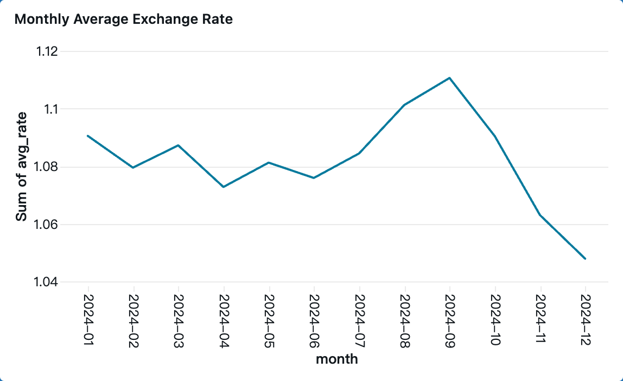
Dashboard 1_Monthly Average Exchange Rate
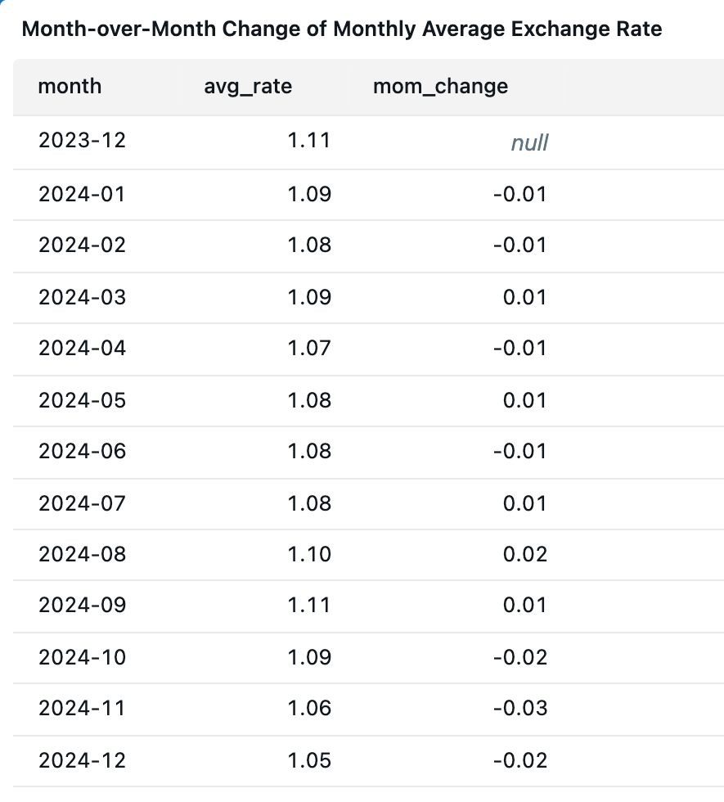
Dashboard 2_Month-over-Month Change of Monthly Average Exchange Rate
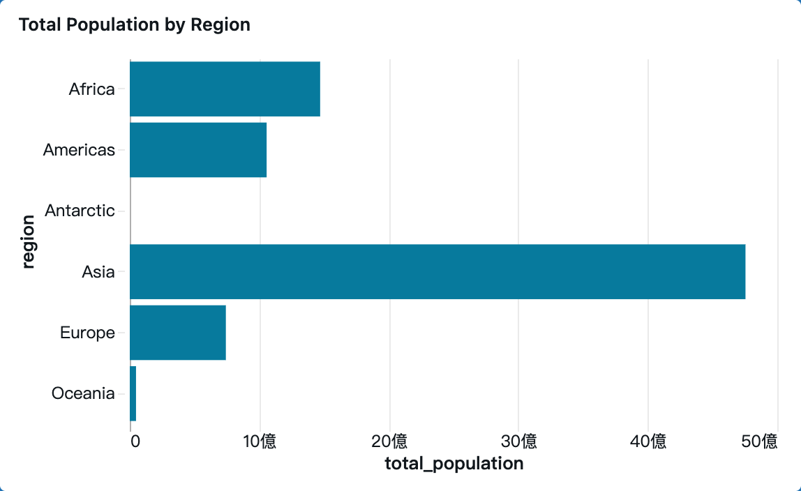
Dashboard 3_Total Population by Region
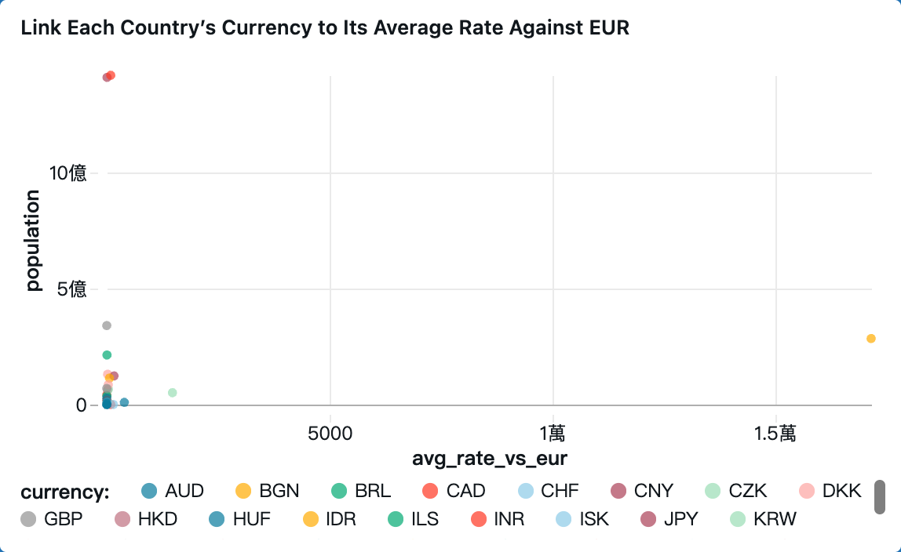
Dashboard 4_Link Each Country’s Currency to Its Average Rate Against EUR

